TensorFlow Playground Presentation

Neural networks are powerful models in artificial intelligence, designed to mimic the way the human brain processes information. They consist of interconnected layers of neurons, which work together to recognize patterns and make decisions. Key components include:

* Neurons: Basic units that receive inputs, apply weights, and produce outputs.
* Layers: Networks typically have an input layer, one or more hidden layers, and an output layer. Each layer can contain multiple neurons.
* Activation Functions: Functions applied to the output of neurons, introducing non-linearity, which enables the model to learn complex relationships.
* Understanding these components is crucial for developing effective neural networks capable of solving real-world problems.

References:

V7 Labs. (n.d.). Neural networks and activation functions. Retrieved from <https://www.v7labs.com/blog/neural-networks-activation-functions>

Task 1 - Activation Functions

Experimentation

* For Task 1, I created a neural network with one hidden layer containing 4 neurons and experimented with different activation functions: ReLU, Sigmoid, and Tanh.

Explanation of Activation Functions

* Activation functions are mathematical equations that determine the output of a neural network's neuron based on its input. They introduce non-linearity, allowing the network to learn complex patterns in the data.

Observations

* ReLU Activation: Produced a strong decision boundary, effectively separating the classes with fast convergence. The training loss was low, demonstrating effective learning.
* Sigmoid Activation: Slower training with a less effective decision boundary, often leading to issues like vanishing gradients, especially in deeper networks.
* Tanh Activation: Improved performance compared to Sigmoid but did not match ReLU's efficiency in this case.

Screenshots:

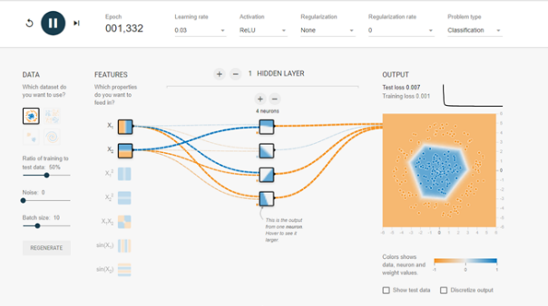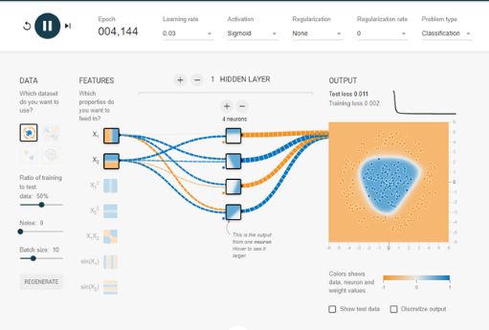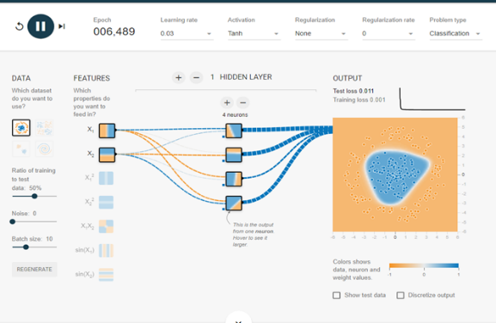

References:

GeeksforGeeks. (n.d.). Activation functions in neural networks. Retrieved from <https://www.geeksforgeeks.org/activation-functions-neural-networks/>

Task 2 - Hidden Layer Neurons

Experimentation

* In Task 2, I modified the number of neurons in the hidden layer and explored the impact of adding additional hidden layers using the XOR dataset.

Role of Neurons and Hidden Layers

* Neurons in hidden layers allow the network to capture complex patterns in the data. More hidden layers can enhance the network's ability to learn intricate relationships, making it more effective at classification tasks.

Observations

* 4 Neurons: The model struggled to form a clear decision boundary, unable to effectively classify the XOR pattern.
* 6 Neurons: Improved performance with a clearer decision boundary, indicating that more neurons helped capture the complexity of the data.
* Two Hidden Layers: Further enhancement of the decision boundary, allowing the model to learn more complex relationships effectively.

Screenshots:

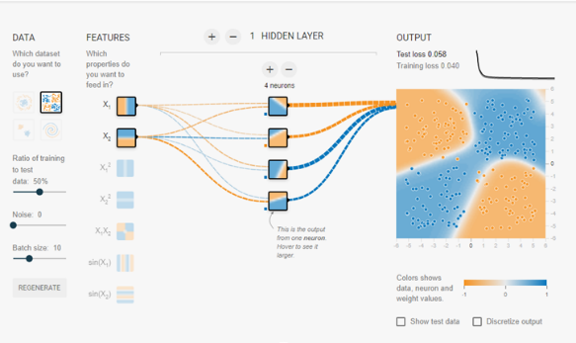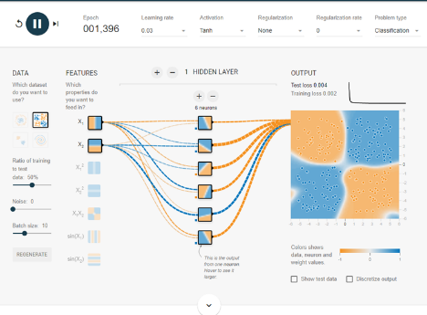

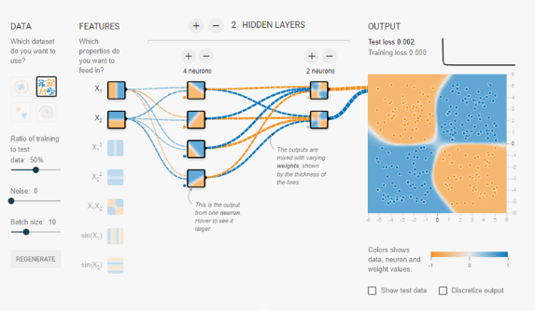

References:

Restack. (n.d.). Deep learning: The answer to hidden layers. Retrieved from <https://www.restack.io/p/deep-learning-answer-hidden-layers-cat-ai>

Task 3 - Learning Rate

Experimentation

* In Task 3, I adjusted the learning rate while using the Circle dataset.

Definition and Significance of Learning Rate

* The learning rate is a hyperparameter that determines the size of the steps taken during optimization. It significantly impacts the convergence speed and accuracy of the model. A well-chosen learning rate facilitates efficient training and helps avoid pitfalls like overshooting the optimal solution.

Observations:

* A higher learning rate speeds up training but can result in instability. Choosing the right learning rate is critical for balancing speed and accuracy in training.
* Learning Rate: 0.03: The model converged effectively with a low training loss and reasonable test loss.
* Learning Rate: 0.3: While it converged quickly, it led to overfitting, as indicated by the difference between training and test loss.

Screenshots:

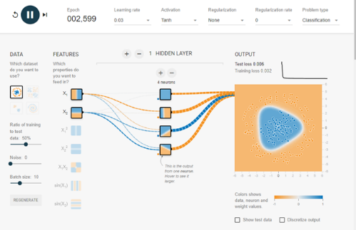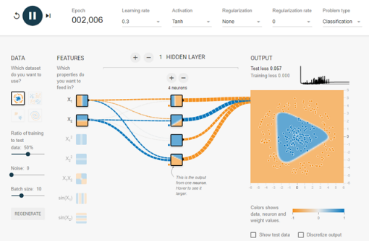

References:

Deepchecks. (n.d.). Learning rate in machine learning. Retrieved from <https://www.deepchecks.com/glossary/learning-rate-in-machine-learning/#:~:text=The%20learning%20rate%2C%20denoted%20by,network%20concerning%20the%20loss%20gradient%3E>

Task 4 - Data Noise

Experimentation

* For Task 4, I introduced noise into the Circle dataset by adjusting the "Noise" slider while maintaining ReLU activation and 4 neurons in one hidden layer.

Explanation of Data Noise

* Data noise refers to random variations in the dataset that can obscure the underlying patterns the model is trying to learn. High levels of noise can hinder a network's ability to generalize effectively.

Observations

* Low Noise Level: The model performed well, achieving low training and test loss, indicating effective learning.
* High Noise Level (50): The performance declined significantly, with much higher training and test losses, demonstrating that increased noise severely affects model generalization.

Screenshots:

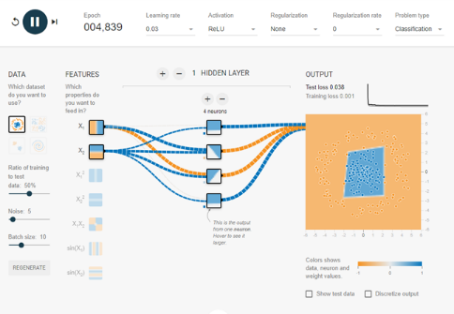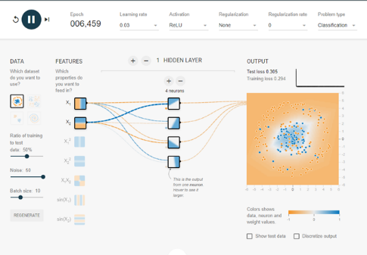

Task 5 - Dataset Exploration

Experimentation

* In Task 5, I explored various datasets available in TensorFlow Playground, including Circle, XOR, Gaussian, and Spiral.

Importance of Dataset Selection

The choice of dataset is crucial in training neural networks, as different datasets have unique characteristics that may require tailored approaches to achieve optimal performance.

* Circle: The network handled this well with even a simple setup.
* XOR: Required more neurons and layers to properly capture the non-linear boundary.
* Gaussian: The decision boundary formed correctly with minimal layers.
* Spiral: The most complex dataset, requiring multiple layers and neurons to approximate the pattern, though it was still challenging for the network.

Observations:

* Different datasets have varying levels of complexity, and the architecture needs to be adapted accordingly.

Screenshots:

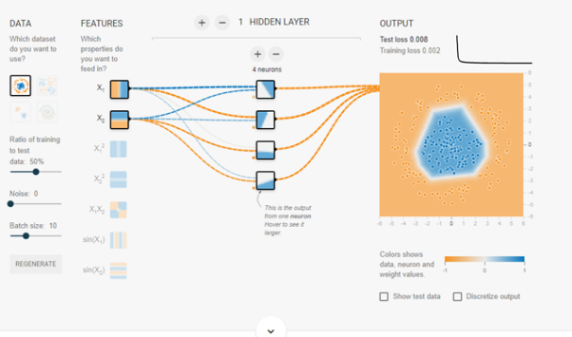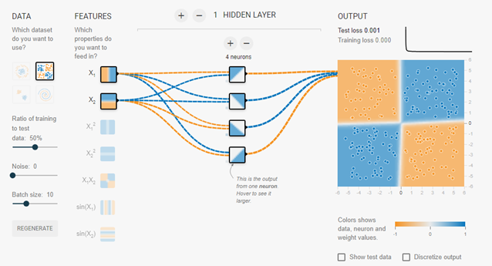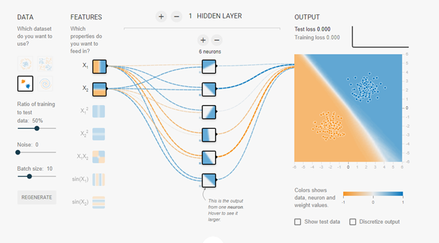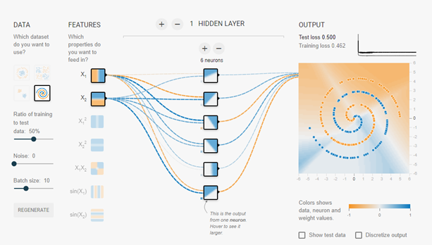

References:

Kezmann, J. M. (2021). The dos and don’ts of dataset selection for machine learning. Retrieved from <https://medium.com/@jan_marcel_kezmann/the-dos-and-donts-of-dataset-selection-for-machine-learning-you-have-to-be-aware-of-8b14513d94a#:~:text=A%20diverse%20dataset%20can%20help,sources%2C%20populations%2C%20or%20locations>

Conclusion

Through this exploration of neural networks, I gained valuable insights into the intricacies of model performance affected by activation functions, hidden layers, learning rates, data noise, and dataset selection. Each task highlighted the importance of parameter tuning and how it impacts the network's ability to learn and generalize.